**Prerequisites:**

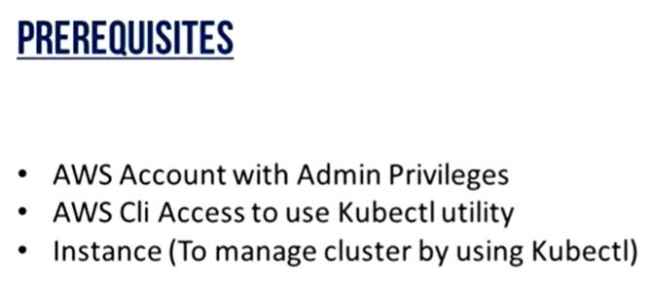

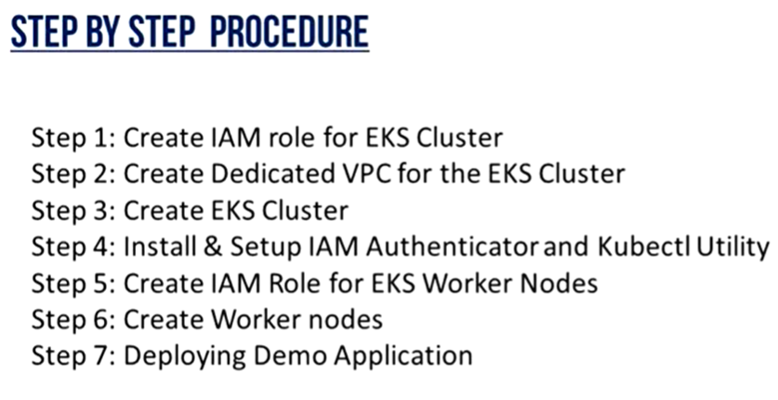

**Create role for EKS**

* Create role for EKS cluster as below. No need to add any other service here.

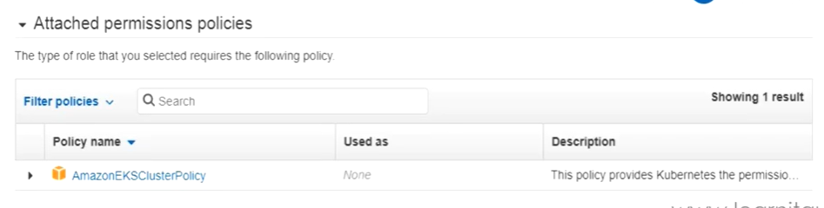

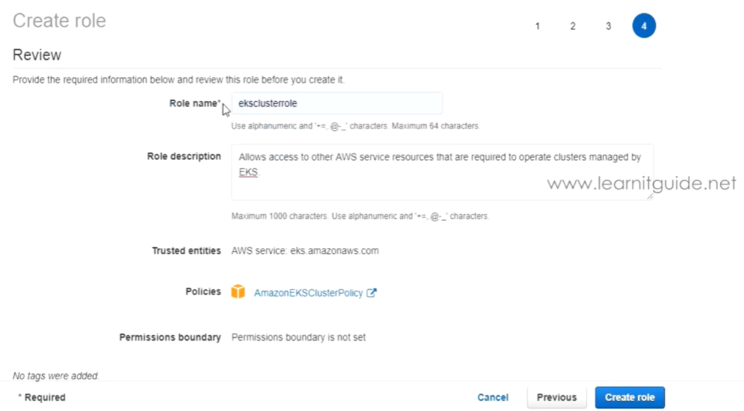

* We may also need to create one separate VPC for EKS

**Creating EKS cluster:**

* Once that is done, we can create EKS cluster as below.

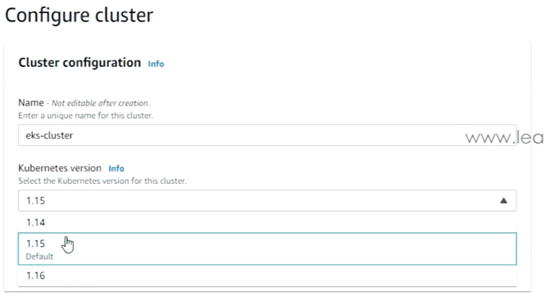

* We need give a name to the cluster with Kubernetes version.

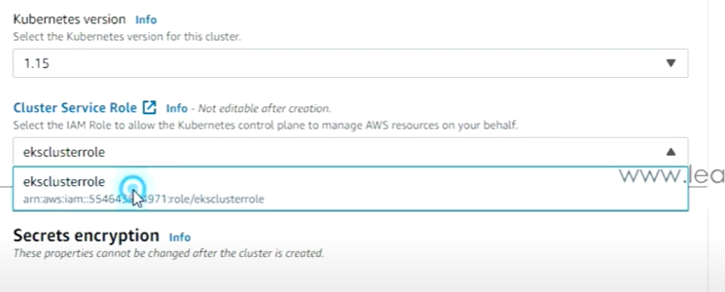

* downside, we also need to choose the role which we selected to let the Kubernetes cluster manage the AWS resources.

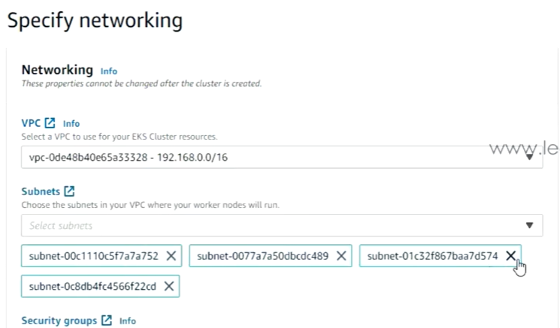

* We also need to select the VPC under networking section as above.

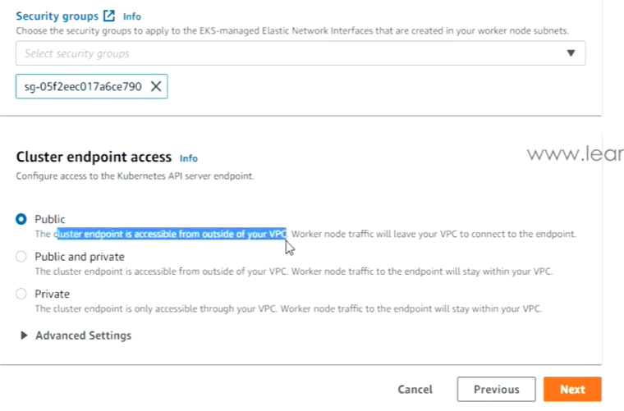

* As then, we can select the security group as above.
* Also, the cluster endpoint either to be public or private or public & private.

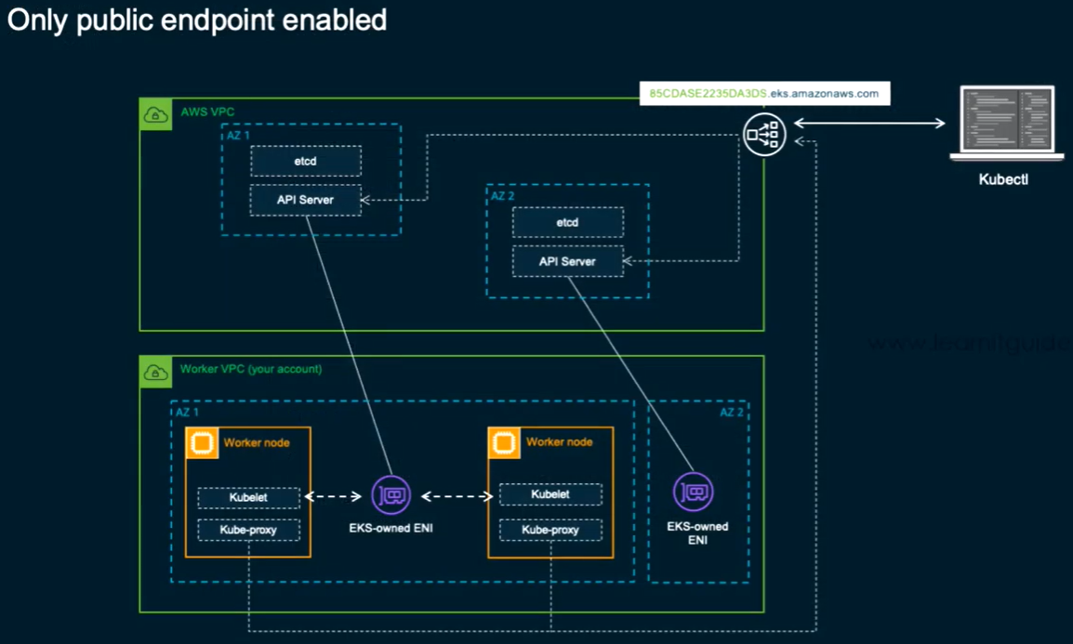

* As above, public endpoint means that cluster API will be accessed from outside of the VPC. But still the worker node will also leave the VPC to connect to endpoint

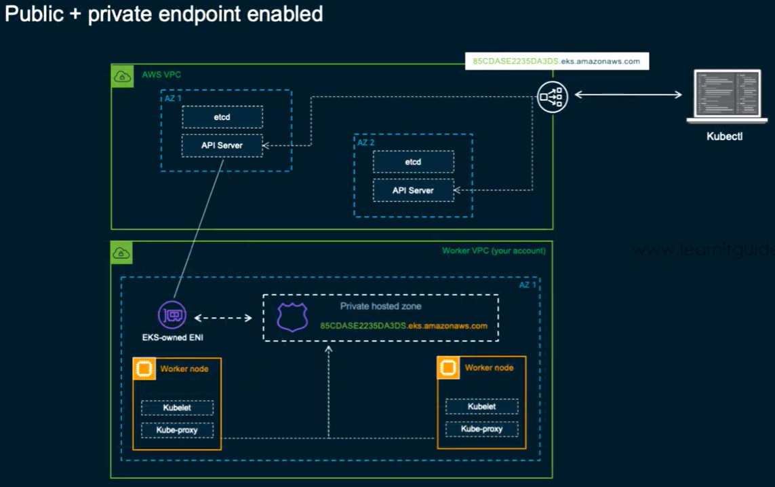

* Public and private means, only the cluster endpoint will be accessed from outside of the VPC. But the traffic of any worker nodes will not leave VPC.

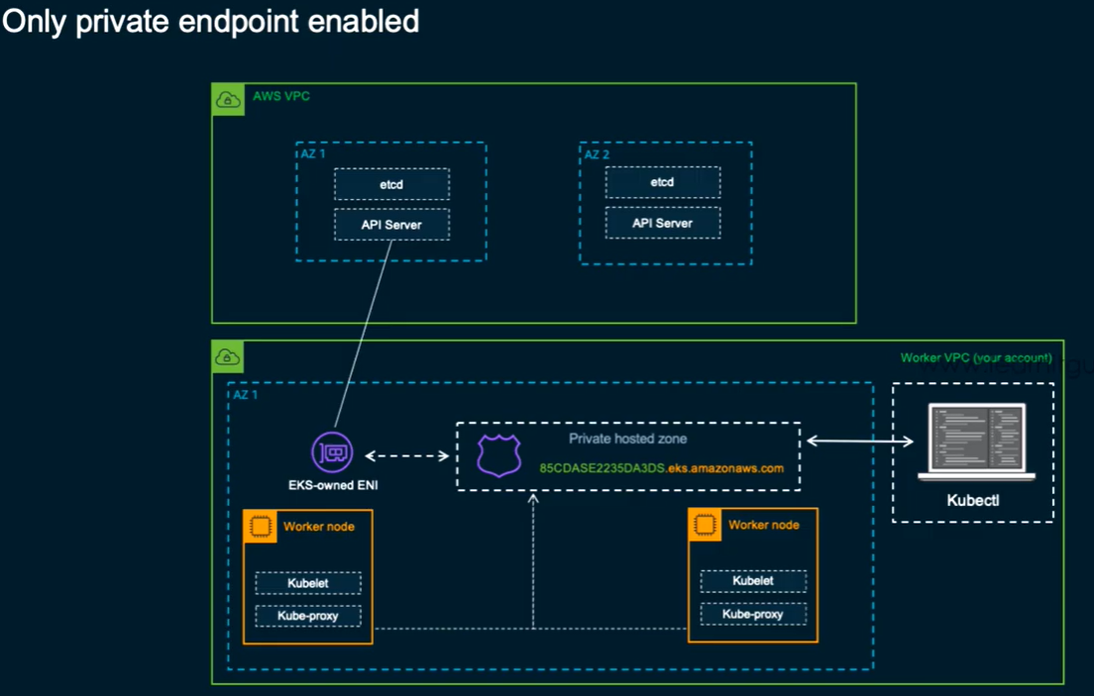

* Here, only from that dedicated VPC, we will be able to access the cluster endpoint. And worker nodes will also stay within the current VPC.

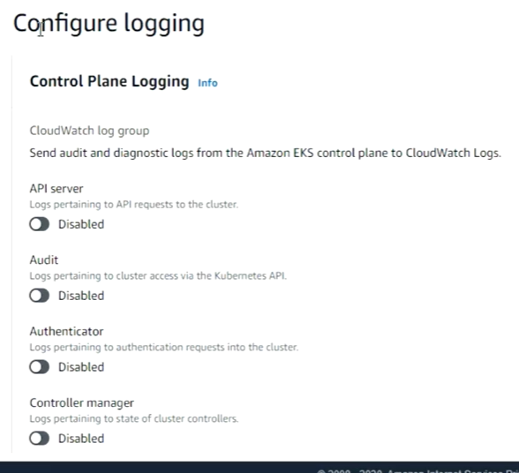

* We can configure the loggers for any of the component in next step as above.

**Accessing cluster from the server:**

* Now, connect to the EC2 instance where AWS CLI is available. We need to install IAM authenticator in that server.
* And also, we need to install kubectl in that server.

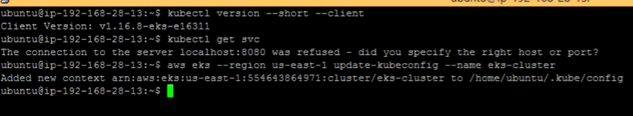

* After that, we need to run above command to add the cluster to the server.
* Now, we will be able to access the cluster from that server.

**Creating role from EC2 & EKS:**

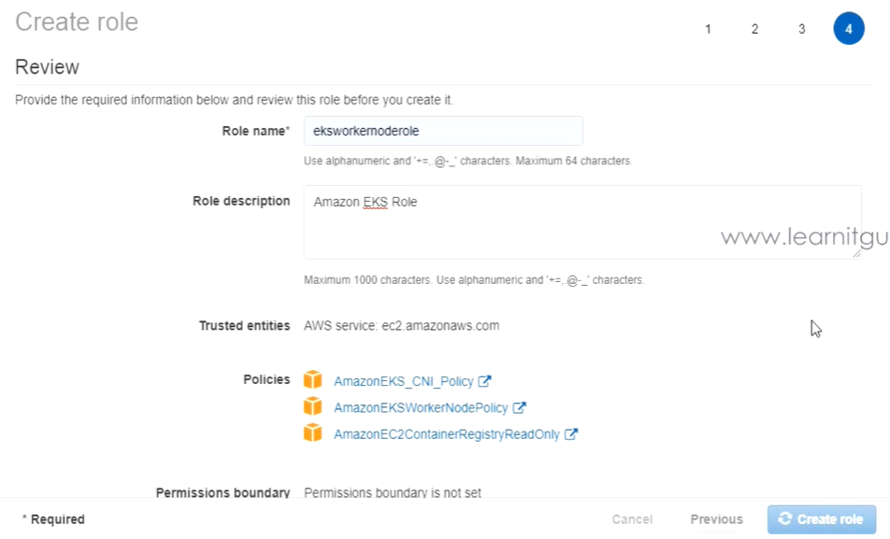

* create role as above with e2s and EKS cluster access.

**Adding nodes:**

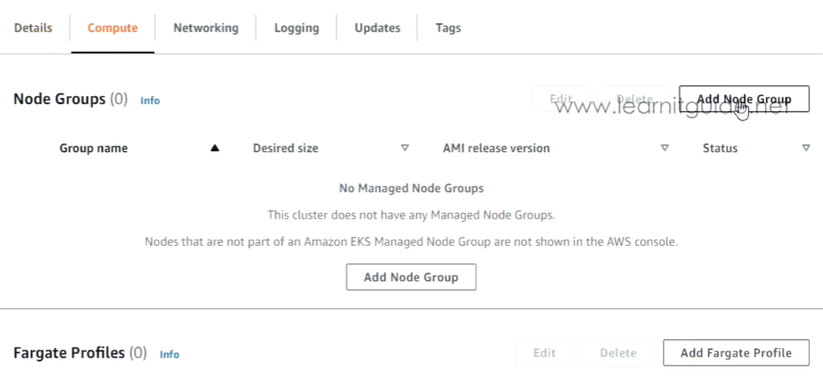

* Under cluster configuration, we need to add node group as above.

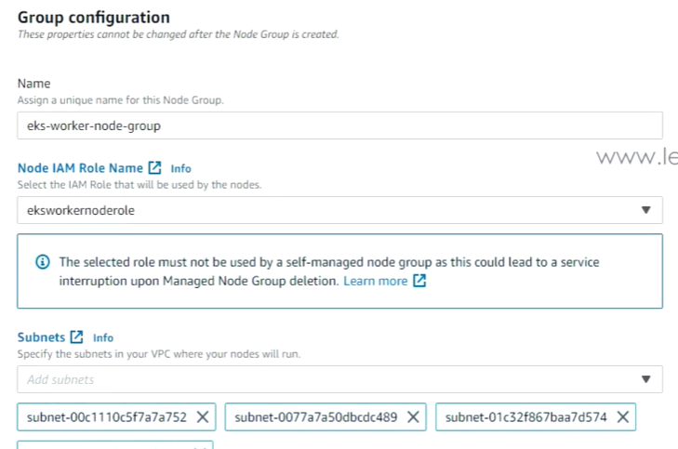

* Give a name to the node group, select the IAM node and by default the subnets will be selected.

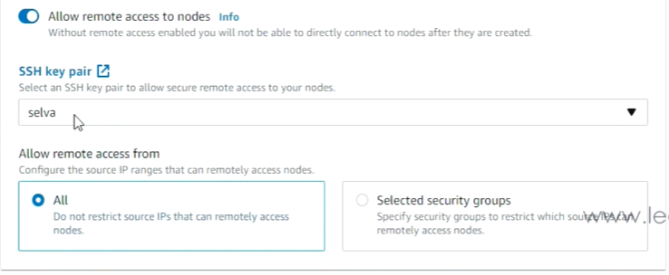

* Below that, if we disable **“allow remote access to nodes”** option. Then we will not be able to access the nodes
* If we enable it, we can select the SSH key pair to access the nodes as above.

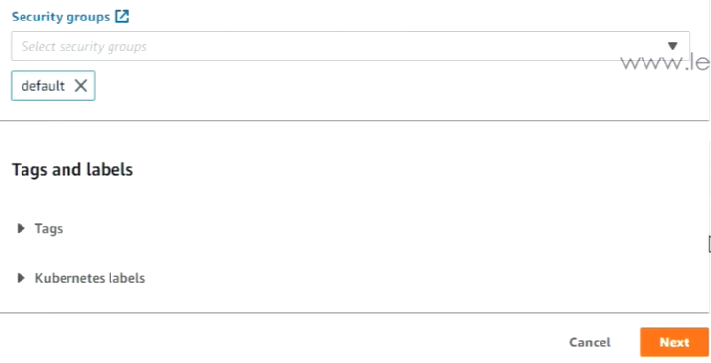

* Select the security group

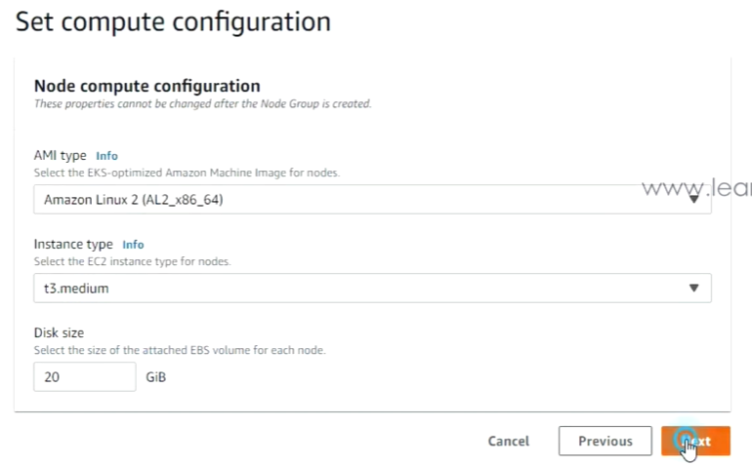

* In next step, we can add the compute configuration as above.

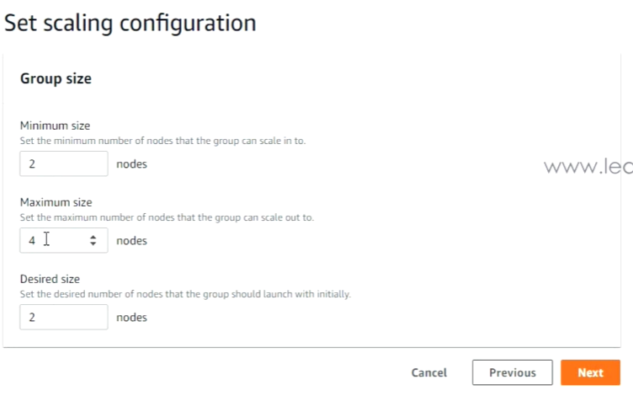

* In next step, we need to select the minimum size, maximum size and desired size for the autoscaling of nodes.
* After this, we can see the EC2 instances in console gets created by EKS.